Data Base Creation

I created a data base in Fire Base with Data Base name as Tensor3.The link I provide here; in which my data base is created is https://console.firebase.google.com/project/tensor3-598ec/database/tensor3-598ec/data.

The screenshots of my data base are as follows:

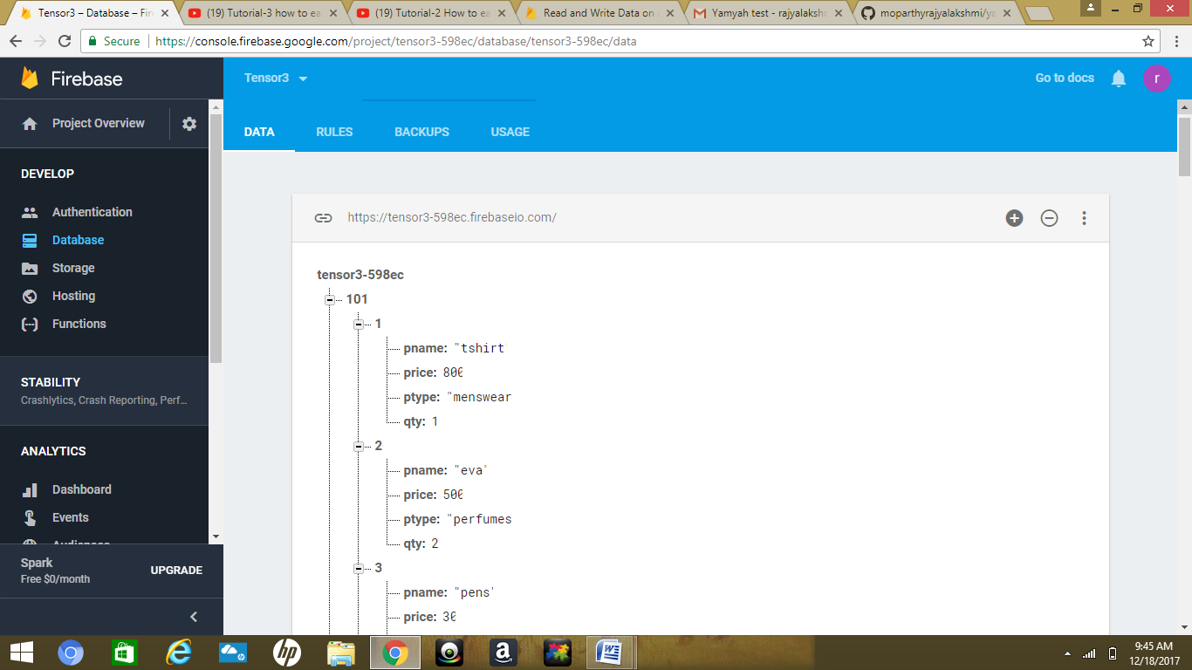

The above screen shot contains 1st customer details.

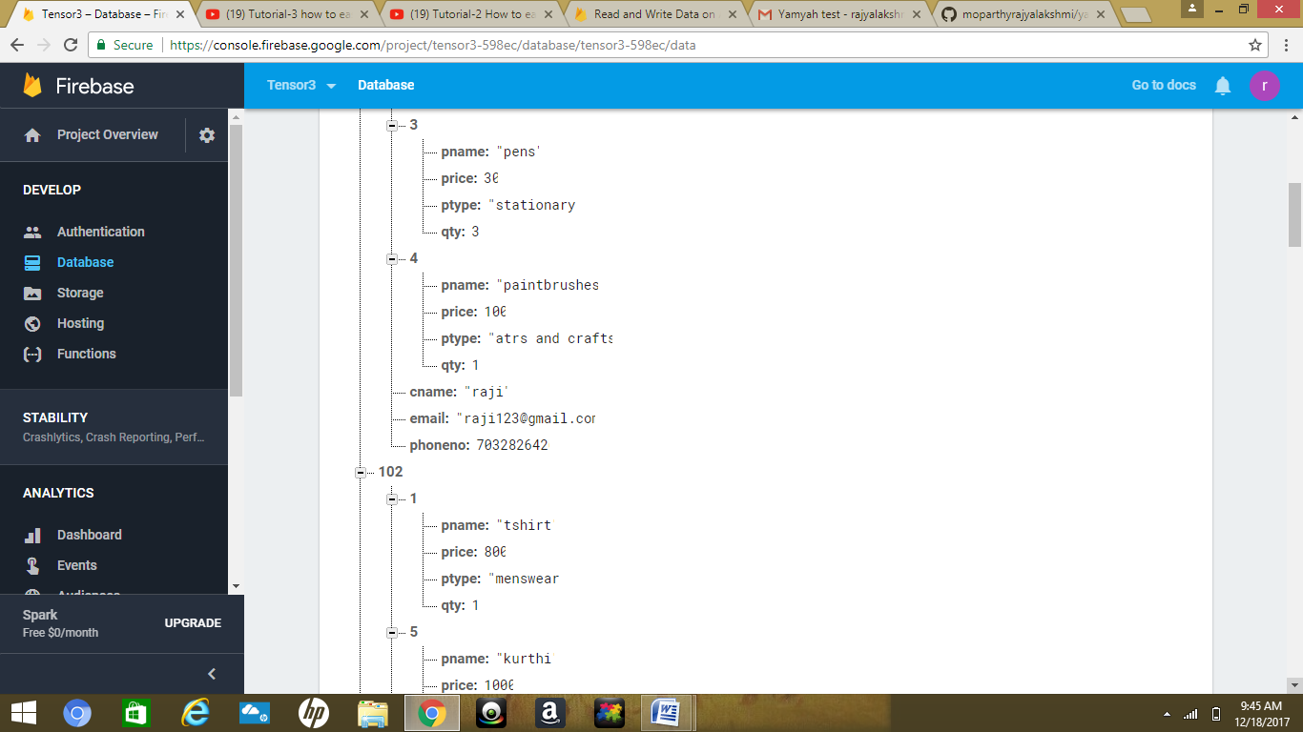

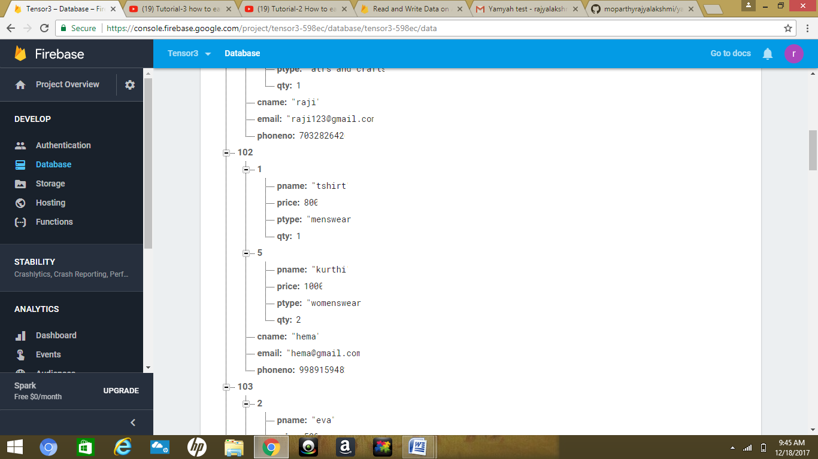



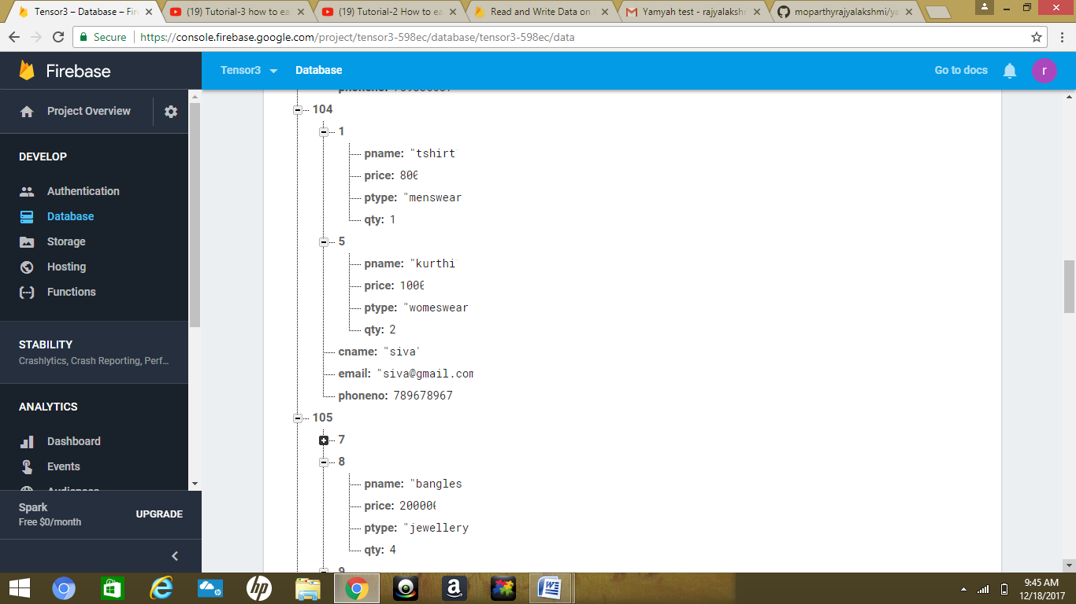

similarly I created a list of 15 customers details. Its available in the following url:

https://tensor3-598ec.firebaseio.com/

Since I created data base by logging into my gmail account my gmail id is: rajyalakshmi.moparthy@gmail.com